Letter of Invitation Request 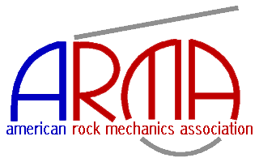

Please type in the information as you would like it to appear on your invitation letter

Save completed form and e-mail to ARMA Registrar
Please check applicable dates of attendance:
☐ 52nd US Rock Mechanics/Geomechanics Symposium June 17 – 20, 2018 only
☐ 2nd International Discrete Fracture Network Engineering Conference June 20 – 22, 2018 only
☐ Both Symposium and DFNE Conference June 17 – 22, 2018

Name
Mailing Address
Country of Origin
E--mail

Authors only
Paper No.
Title
Please indicate if ARMA or DFNE | ☐ ARMA ☐ DFNE
Paper No. (if applicable)
Title
Please indicate if ARMA or DFNE | ☐ ARMA ☐ DFNE
Paper No. (if applicable)
Title
Please indicate if ARMA or DFNE | ☐ ARMA ☐ DFNE

Special Requests
Please use this block to list any special requests you would like included in your letter

